***Hotel management – IT20152246 (Sonali L.D.A.)***

**CRUD operations and the entire functionality of the component.**

Our app is “Triposo” tour guide application. This part belongs to hotels and restaurants. In this function, both user and admin can search for hotels. And in here only admin has access to handle these three functions ADD, UPDATE and DELETE.

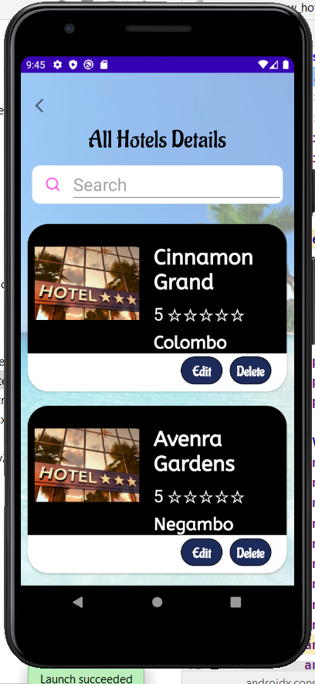SEARCH Hotel - By search bar, users can search a city that they need, or in below, there is a dropdown list and by using it also you can easily search your places. After searching for your city or district all the top destinations can be seen. By search result menu, you can see the main details of each hotel and if you need more details by clicking view details you can enter that hotel page. There you can see an overview of the hotel and on that page, you can see full details of the hotel.

By changing another tab, you can choose your rooms, hotel package’s and their prices. And also, by amenities tab users can easily see the facilities of each hotel. And some hotels will display their discount packages and extra-facilities which given by them in their amenities tab. If users are interested in packages they can contact through calling or sending a mail to hotels. And these parts belong to the frontend side of the application.

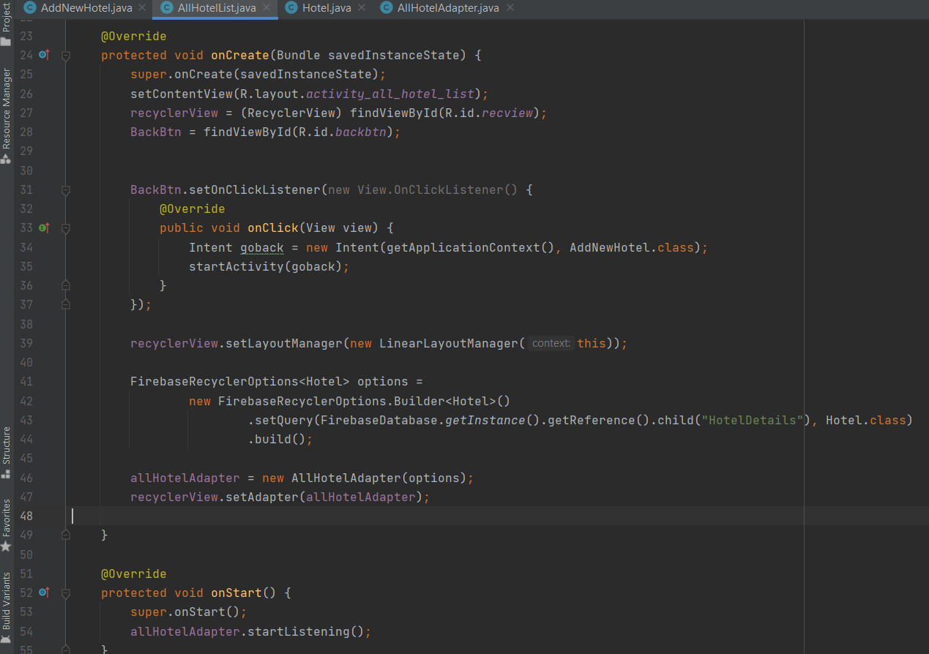

ADD New Hotel - By add hotels function, admin can add hotels to the app. Mainly hotel name, district, hotel type, location, prize details of hotel packages, phone, and a brief description of the hotels can be added. All the fields must be completed. When the admin adds details of a hotel and by clicking “Add Hotel” button, system will display a success notification.

And in here, all the fields such as hotel name, district, type, address, price and contact are consisting of validations. Also, in here, any of the field should not be kept empty without recording data. Therefore, all the required fields should be filled in order to add details of a new hotel.

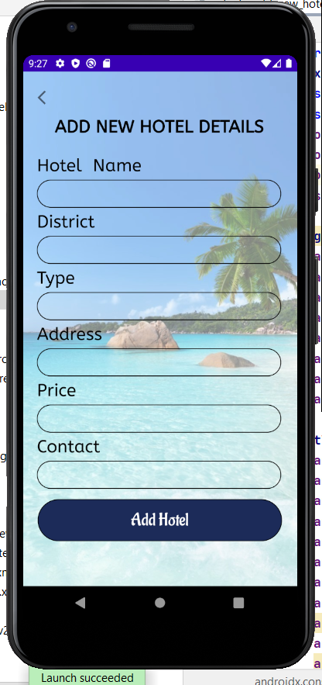

After recording data to all the required fields, admin can click Add Hotel button. So, after clicking Add Hotel button system will check the validations and if the recorded details are valid then it will display a toast message as “Hotel is created successfully”. So, after displaying this toast message, the inserted details will be recorded in the database successfully.

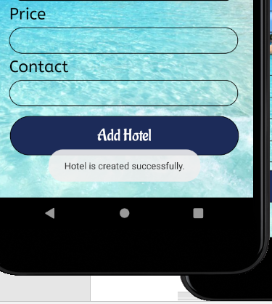

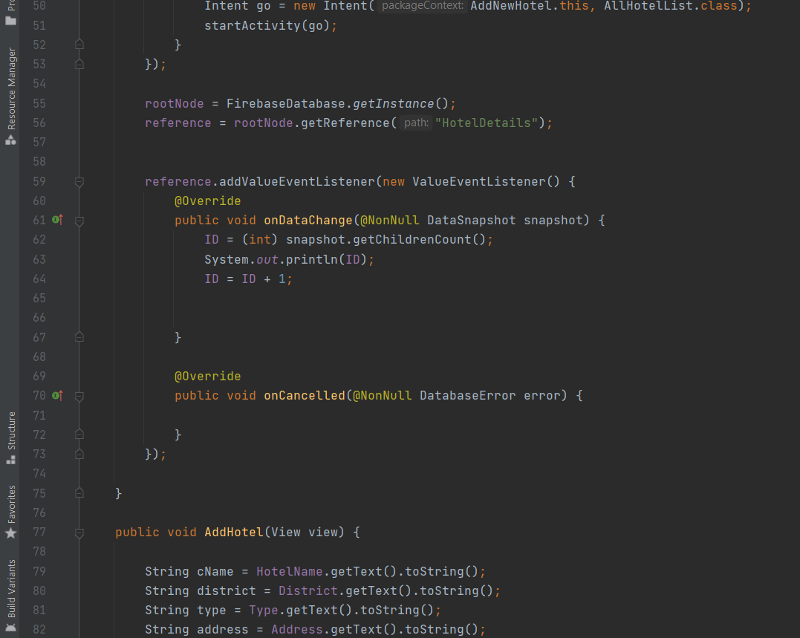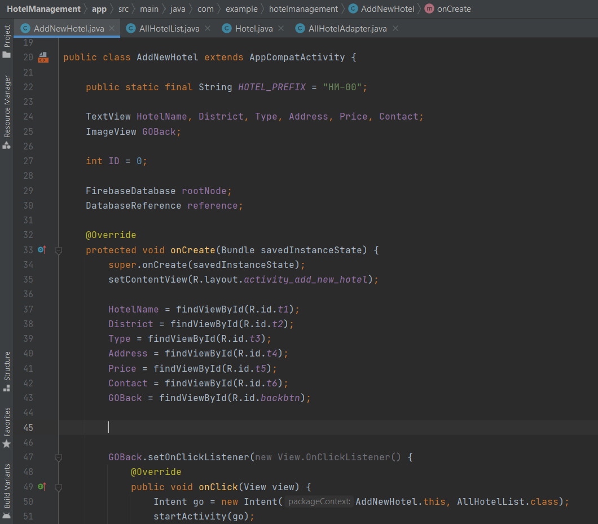

*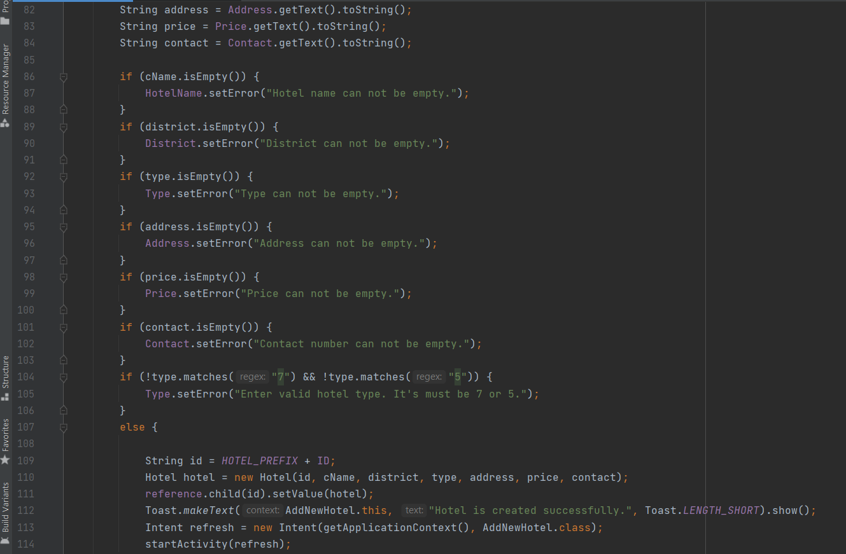Validations are done according to the below code ;-*

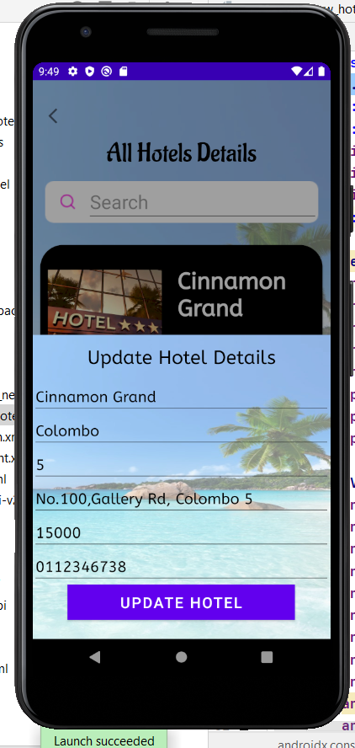UPDATE Hotel details - All the details hotel name, district, hotel type, location, prize details of hotel packages, phone, and the brief description can edit from the update hotel details form. Admin can easily edit the relevant details by clicking UPDATE button.

After clicking the update hotel button, the edited details will be updated successfully in the database.

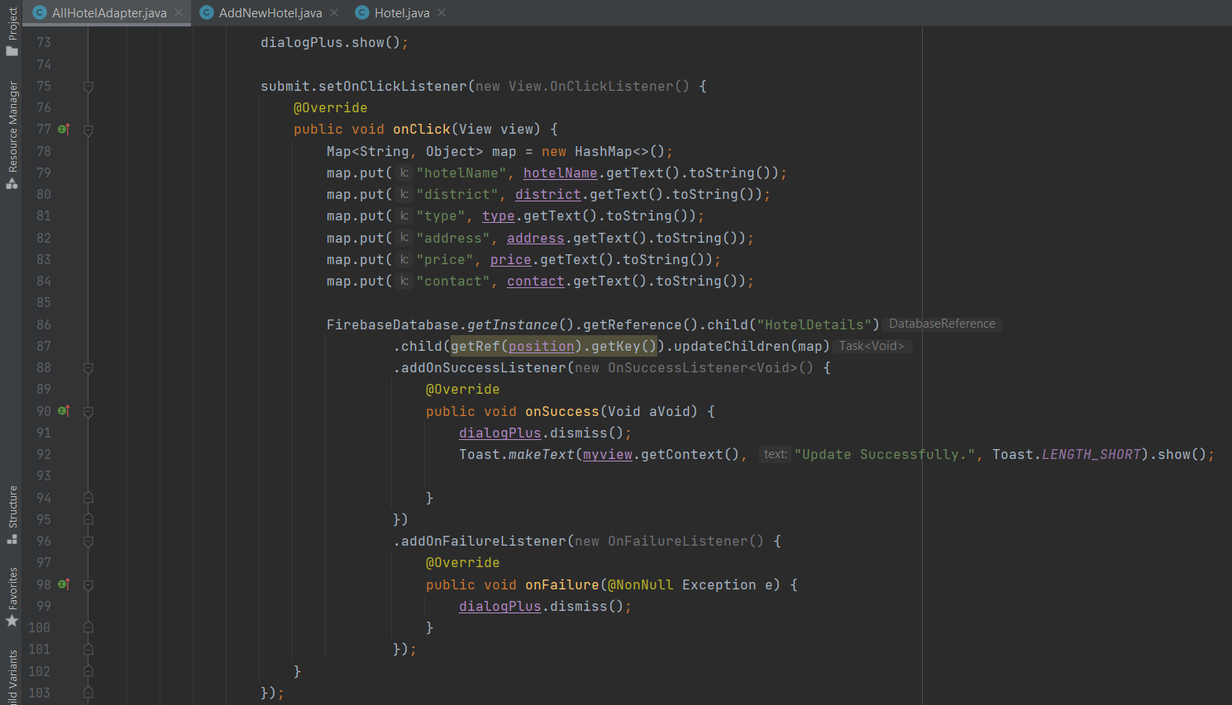

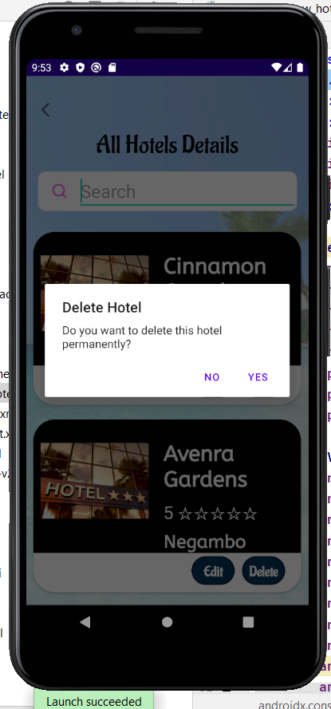

DELETE Hotel details - If admin wants to delete any hotel due to any reason admin can do easily from the delete section. By clicking DELETE button confirmation message will appear. By confirming it, admin can delete relevant hotel details successfully.

And above all these CRUD functions are belonging to the backend of the application.

Finally, hotels can calculate the payments of the users relevant to the rooms which they booked. Rooms have different prices due to consist of extra-facilities such as A/Cs, heaters, refrigerators and bed sizes. And some hotels will give 10% discounts for SAMPATH and BOC debit card users.

